Project Design Phase-II

Data Flow Diagram & User Stories

Date | 15 February 2026
Team ID | LTVIP2026TMIDS47425
Project Name | IntelliSQL: Intelligent SQL Querying with LLMs Using Gemini Pro
Maximum Marks | 4 Marks

Data Flow Diagrams:
A Data Flow Diagram (DFD) is a traditional visual representation of the information flows within a system. A neat and clear DFD can depict the right amount of the system requirement graphically. It shows how data enters and leaves the system, what changes the information, and where data is stored.

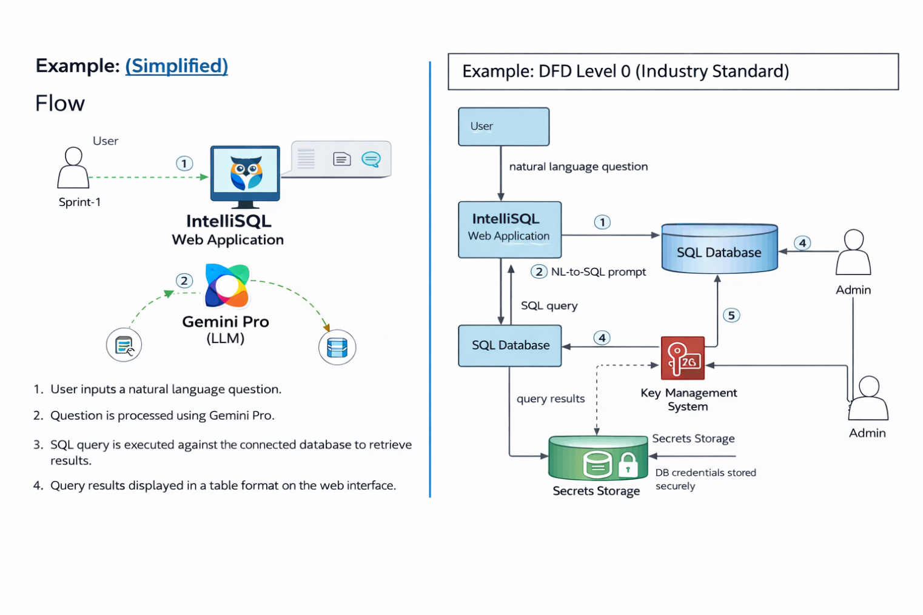

User Stories
User Type | Functional Requirement (Epic) | User Story Number | User Story / Task | Acceptance Criteria | Priority | Release
Customer (Web User) | User Authentication | USN-1 | As a user, I can register using email and password. | Account created and dashboard accessible. | High | Sprint-1
Customer (Web User) | User Authentication | USN-2 | As a user, I receive confirmation email after registration. | Confirmation email received and verified. | High | Sprint-1
Customer (Web User) | Login | USN-3 | As a user, I can log in using email and password. | User successfully logs into dashboard. | High | Sprint-1
Customer (Web User) | Natural Language Query | USN-4 | As a user, I can enter a natural language question. | Query submitted successfully. | High | Sprint-2
Customer (Web User) | SQL Generation | USN-5 | System converts NL query to SQL using Gemini Pro. | Generated SQL is syntactically correct. | High | Sprint-2
Customer (Web User) | Query Execution | USN-6 | System executes generated SQL on database. | Results retrieved successfully. | High | Sprint-2
Customer (Web User) | Result Display | USN-7 | User can view query results in table format. | Results displayed clearly. | High | Sprint-2
Administrator | Database Management | USN-8 | Admin can configure database connection settings. | Database connects successfully. | High | Sprint-1
Administrator | Security | USN-9 | Admin securely stores database credentials. | Credentials encrypted and protected. | High | Sprint-1
Administrator | Monitoring | USN-10 | Admin can view logs of executed queries. | Query logs stored and visible. | Medium | Sprint-2

